Plainis, Sotiris, and I. J. Murray. "Reaction times as an index of visual conspicuity when driving at night." Ophthalmic and physiological optics 22.5 (2002): 409-415.

Task: driving reaction time towards detection of objects (in this case a cross in the center of screen)

Key modeling assumptions: human visual system under mesopic lighting conditions

Attack: manipulation of contrast of symbology; requires access to HMD.

Horizontal axis: 1/C where C is the contrast as defined $≡2ΔL/(L_{avg})$ See Michelson
Vertical Axis: reaction time in ms..

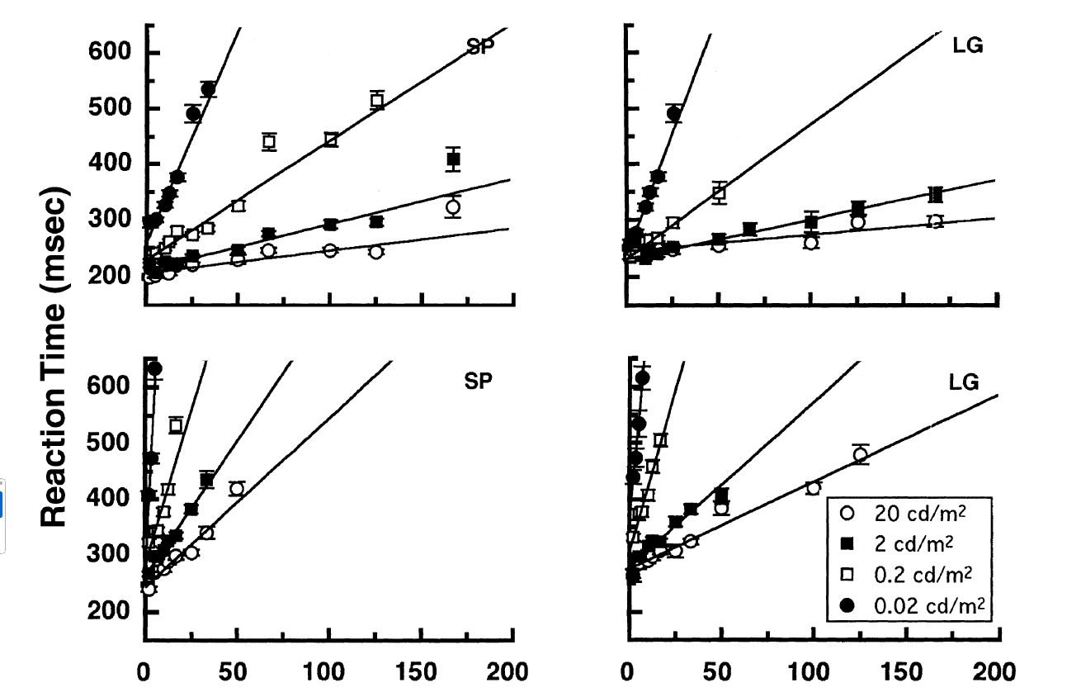
Linear Models:

Plainis and Murray (2000) derived a similar monotonic function when RT was plotted as function of
stimulus contrast, with the exponent being equal to:
$$RT=RT_{0}+kC^{-1}$$
where C is Michelson contrast and k is a constant which characterizes the steepness of the curve.

AGREE model: encodes a discretized version of SP line for ambient luminance of 20 cd/m^2 (circled in red on the figure) for $C^{-1}$ between 0.1 and 50. Spatial frequency: high., Eccentricities: 0 deg i.e. straight on..

Our scenario: military driving operator HMD with MR indicating objects in environment with a cross..

https://github.com/loonwerks/MATRICS/tree/main/Models/Perception/contract_based/Contrast

